Level 1 Report competitive analysis

***Link to prototype:*** [***https://xd.adobe.com/view/9a692588-7baf-4943-a535-0b8621335a68-cf3a/***](https://xd.adobe.com/view/9a692588-7baf-4943-a535-0b8621335a68-cf3a/)

This report analysis a digital planner application. Underlining the purpose, goals and functions, by analysing users. Which is displayed in a vision statement and user story and use cases. Moreover, the level 1 prototype is compared to two other digital planner applications. Which are any do and Notion analysing the limitation and capabilities of both apps and comparing them to the level 1 prototype. Therefore, identifying improvements and recommendations for the level 1 applications.

## Part 1 User analysis and discussion

### Vision statement

Students from university, TAFE, and high school or individuals in a professional environment. A problem these users may encounter is finding a simple and easy way to keep their work tasks and schedule their day. Which keeps their basic daily planner functions are kept in one place. Therefore, the prototype of a digital daily planner application was developed. This solves users' problems of having a very simple and easy way to keep track of tasks and sort them into lists and when these tasks should be done by. Features and functions are not too advanced in the application, as the aim is to provide a simple alternative to the user's physical planner which can be with them anywhere as it's on their mobile phone. This is different to competitors as they have more complex features which can become an overload of information to users and users maybe become confused, thus the simple approach to the app.

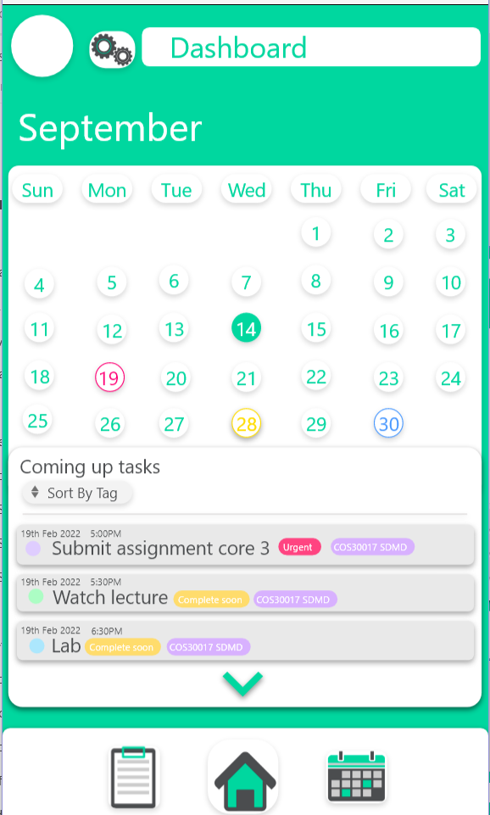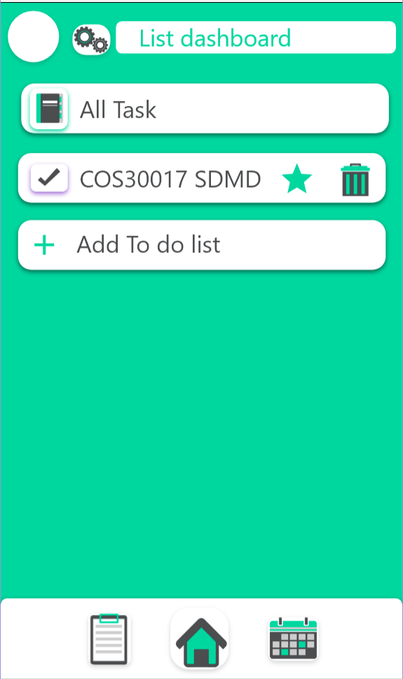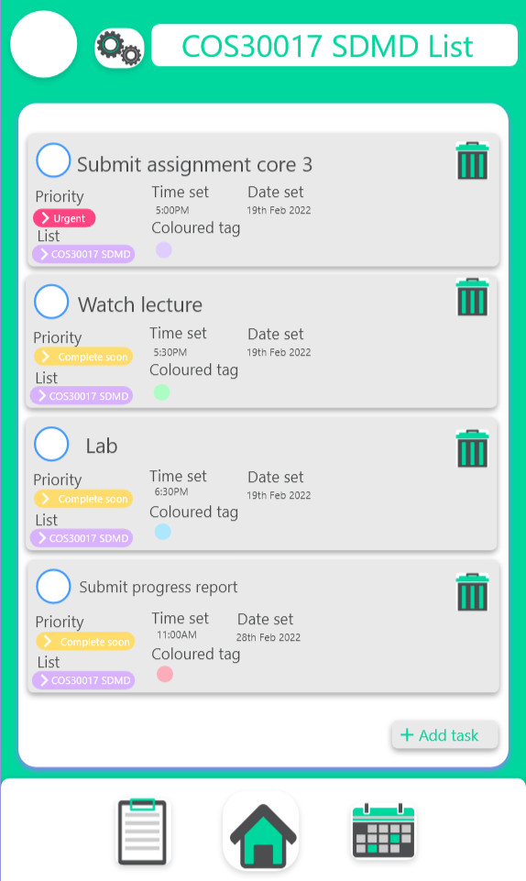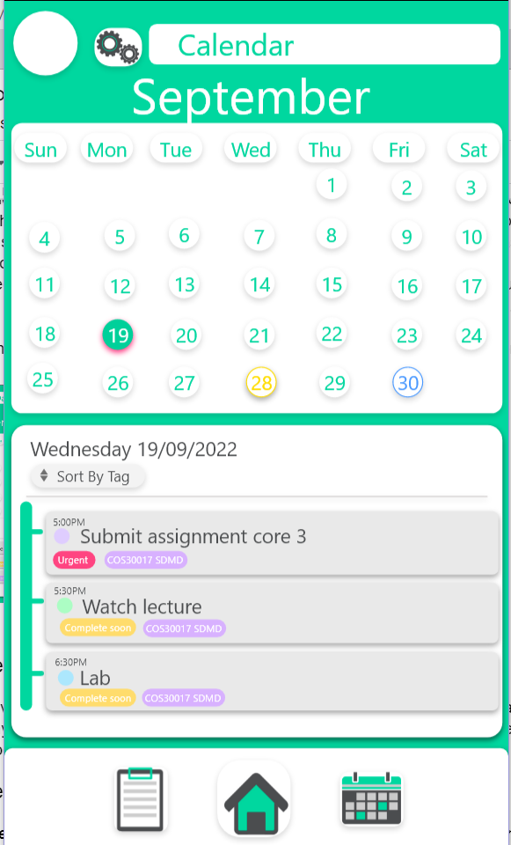

### Create user story

As a university student, I would like a simple and easy way to schedule all the tasks I have to do for my classes, in one place, ultimately assisting me more efficiently organise myself for the school year.

### Create a use case

***Purpose: A university student wants to use the create new list and tasks in that list***

1. Click the List button on the navigation bar → Open lists activity with all lists.
2. Click on add list button → Opens an add list information widget where the user will enter list details.
3. Click on the done button in the list information widget → Adds the list.
4. Click on a created list → Opens the list with all created tasks.
5. Click on add task button → Opens the task information widget where users enter task details.
6. Click on the done button in the task information widget → adds a task to the list the task was added in where the newly created list will be displayed in the list activity.

***Purpose: Sort by date***

1. Click the calendar button in the navigation bar → Open the calendar activity
2. Click on the sort by tag button → Opens the sort by menu
3. Click on the date button → Open a date spinner UI where the user will adjust the date to sort by
4. Click the tick button → All tasks on that date will appear on the bottom half of the screen and a date tag will appear next to the sort by tag button.
5. Click the cross button located on the date tag → Returns all tasks to a default view without filtering

***Purpose: Sort by priority***

1. Click the calendar button in the navigation bar → Open the calendar activity
2. Click on the sort by tag button → Opens the sort by menu
3. Click on the priority button → Open a list of priorities, hence select the wanted priority
4. Click the tick button → All tasks which have been tagged that priority will appear in the bottom half of the screen and a priority tag will appear next to the sort by tag button.
5. Click the cross button located on the priority tag → Returns all tasks to a default view without filtering.

## Part 2 UX comparison

### Notion

Is a digital planner software that users use to manage their daily lives, education work or manage projects. The layout and default design of the application is simply black and white and the addition of colour is more up to the user.

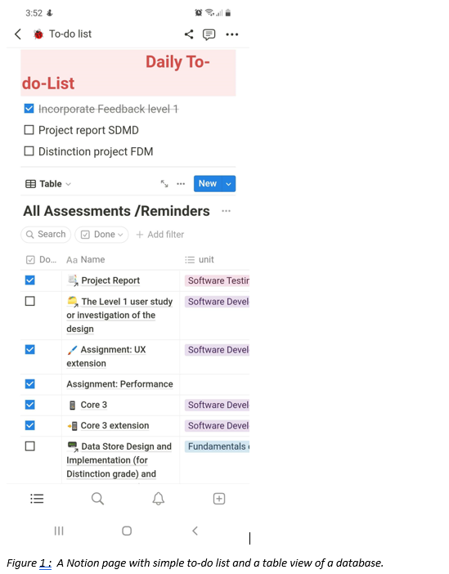

Features analysis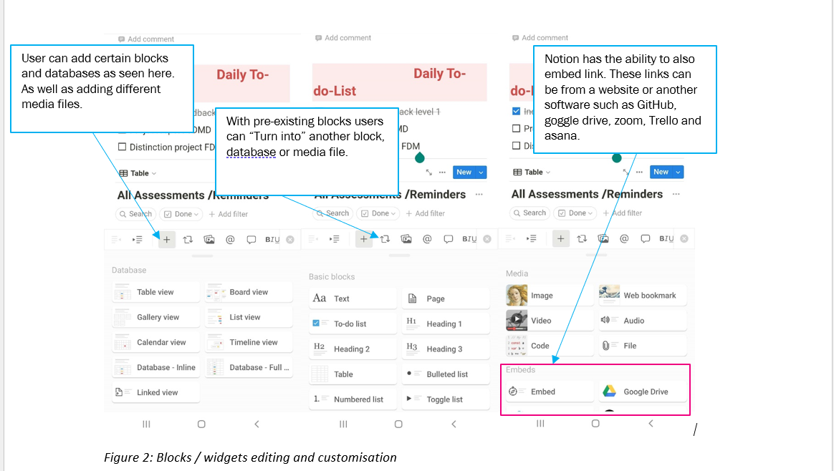

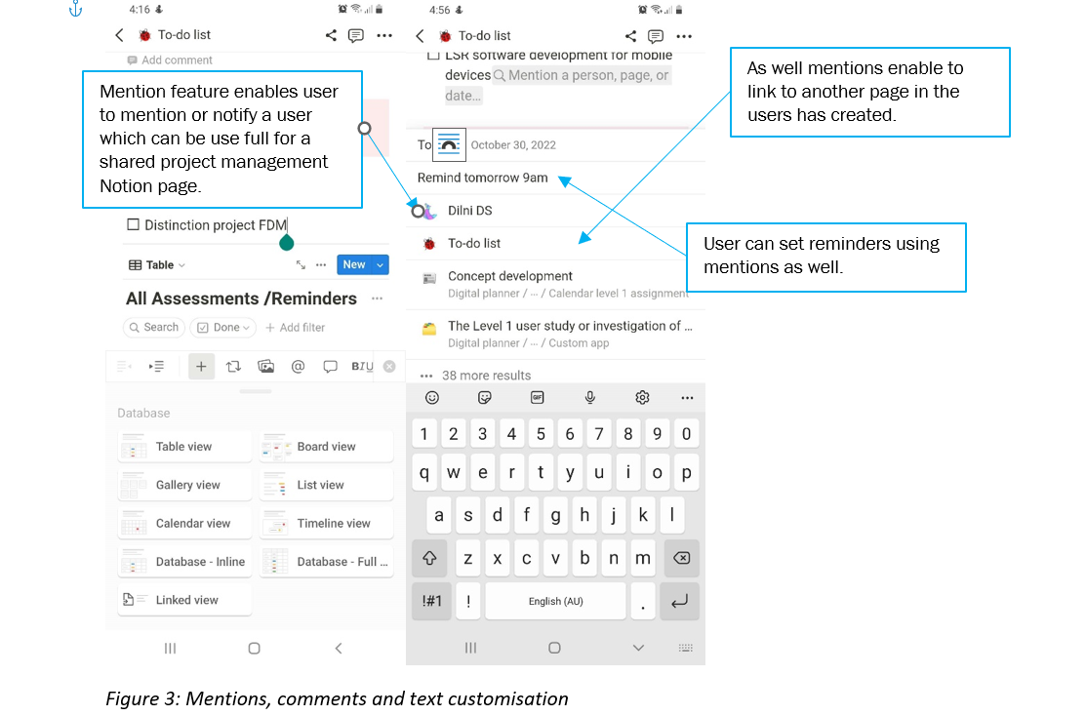

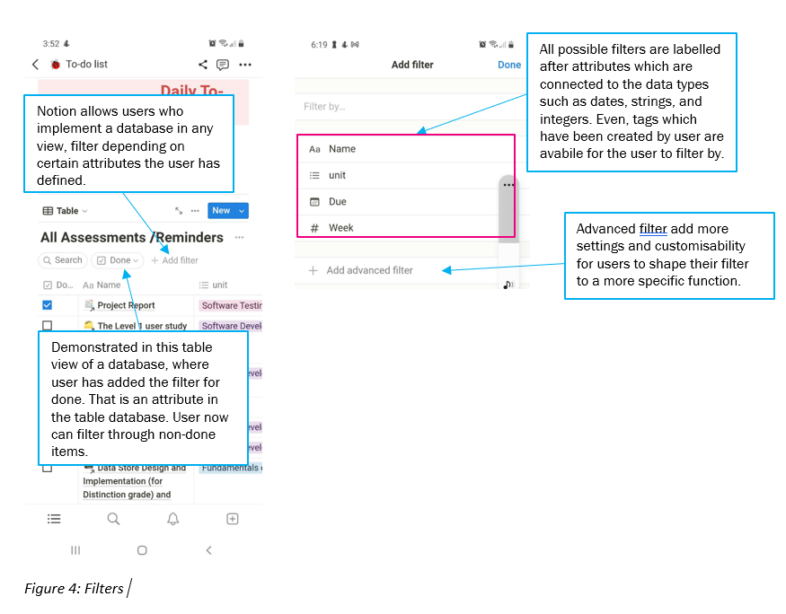

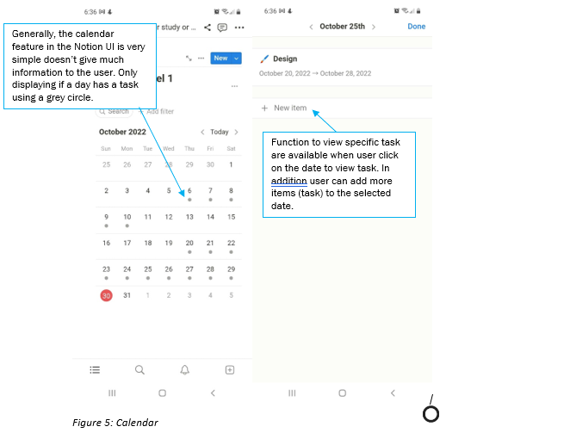

Capabilities

Evidently, through the above analysis, that notion is a very flexible and versatile app. Where

users can customise blank pages to match their needs and wants for a digital planner.

Using blocks with different features and functionality, but ultimately all connect to each other directly by using linking using mentions or callbacks. In addition, users can add images, videos, and audio files as well as customise the text on the Notion pages.

Limitations

Notion, even though is very flexible and has a lot of functionality, has problems concerning presentation on the mobile device itself. Demonstrated in figure 1 where UI looks squished and not correctly displayed on the phone. Where it appears that the interface of the computer/web version of put on a smaller screen without the thought of re-sizing titles, blocks and media files. This makes the application hard to use as the UI is not properly visible and certain functionality hard to perceive is available to the user, such as certain parts of a table database view.

## Comparison

Notion is evidently more complex than the presented level 1 app, the features are more complex and the volume of features is more apparent. Such as the inclusion of different types of blocks and how those blocks can be organised, sorted and viewed by the user. However, this complexity and more features are good and enable users to manage their tasks all in one place without having to move around applications. Where my application doesn't have this much detail just demonstrating a to-do list with tasks in them and a calendar to set due dates and times.

Moreover, Notion is demonstrated to be almost a database that uses blocks to present and organise that data hence allowing blocks to be flexible enough to be turned into another due to this connectivity. Whereas the level 1 application is more concentrated on writing down the task and having them saved into lists than would be saved into a database. Furthermore, both the level 1 prototype and Notion use UX design patterns such as filtering search functions, navigation bars, and settings.

But as identified previously Notion appears to feel like all the functionality of the computer version was compiled into the app version, even though some functionality isn't as clear in the app version such as the database component and the customizability of calendars. In addition, the rendering and sizing aren't as well done in the Notion app where certain things are dont fit onto the screen. To improve the level 1 project it is recommended that more customizability for users be added so users can reply in one app entirely and then use other apps or software to fill the gap of the level 1 prototype. Also adding a grab and move function to move tasks and lists.

### Any do

Any do is a simple digital planner application that aims to help users with productivity, using calendars and lists to help users plan tasks and important dates. It has a default colour palette of white, light blue and shades of black and grey.

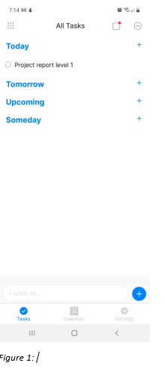

Features analysis

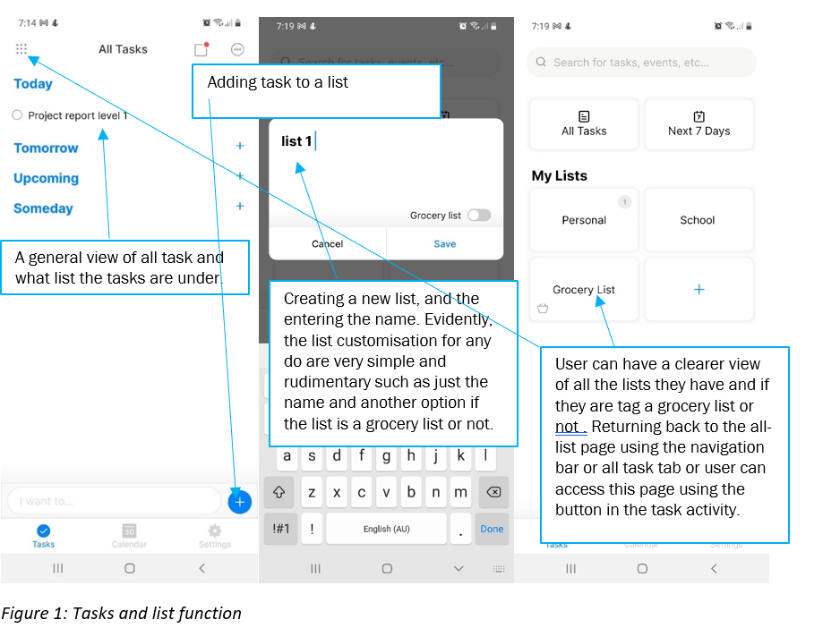

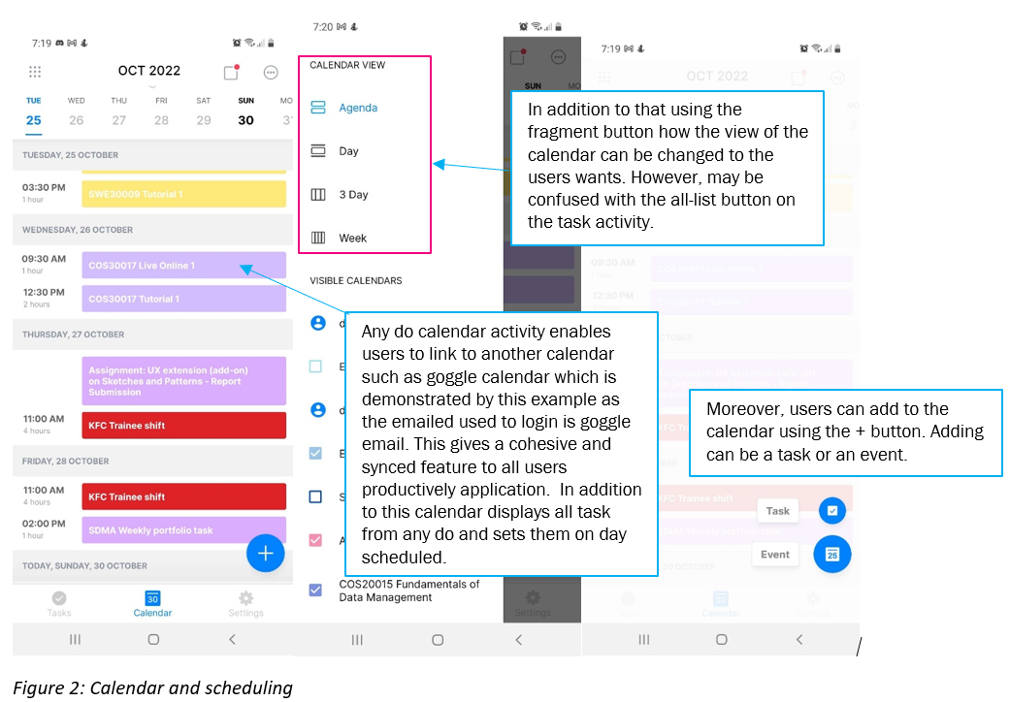

Capabilities

Any is a very simple application that effectively allows users to organise themself and the work they have to complete. As well as scheduling the task to the appropriate dates, with references to other events and tasks which can be loaded in using existing calendars.

Limitations

Generally, the limitations are not that apparent in this application, as the design and layout are clear and simple and the feature and functions are easy for the user to understand and use. As the app doesn't do anything over complex and more crame a lot of functions to an app. However, there is an issue with communicating certain buttons such as the fragment button in the calendar activity vs the all-list button in the list button in the task activity. As they use the same button which may confuse users with what the button does. Such as wondering the if it's a fragment button or a button to another page.

## Comparison:

Any digital planner application has very functionally similar to the level 1 prototype as both have similar functionality of list and task and those tasks being put into the list. However, designs for each have some dramatic differences. Such as a more simple navigation bar with only three options, as well as no determined home page. Evidently, the design is a more polished version and has more consistency the level 1 prototype button some times are flat were other times some more risen. Whereas any do button has a consistent format. Furthermore, a recommendation would be to have a designed and certain type of button for the level 1 prototype. The Colour of the any has more consistency than the level 1 prototype as it only has blue, white and a shade of grey. Whereas the level 1 prototype green and white are consistent but the grey has inconstancy which is not fully visible but may cause issues with more detailed features later on.